The St. Peter Claver Society's July 8-9 second collections will pay for tuition for the following four young adults, who live at the Cardinal Mazombwe Agricultural and Life Skills Centre in Zambia. They need $4,500 to help them complete their second year of studies.
ALICK ZIMBA, 22, who is taking a three year course at the Chongwe School of Education. Alick reports: I have loved the teaching profession since I was a small boy and I really have been inspired by friends who have done teaching. My future plan is to look after my two siblings who are still at school, I would love to give them the best I can.
THOMAS NJOLE,20, who is studying nursing at St. Luke's School of Nursing. Thomas notes: I chose nursing because of my desire is to serve people lives. My future plans are to educate my young sisters and brothers and also to help other vulnerable children.
JONATHAN ZULU, 24, who is taking a three year course in plumbing and sheet metal at the Ukwim Trade Institute. Jonathan reports: I have been interested in this course since grade nine. My uncle used to take me with him to his workplace so I observed everything he did. My desire is to get more knowledge. My plan is to build a house for my parents and to support my three siblings all through their education.
REGINA CHULA, 19, who is enrolled in a seven year course in medicine and surgery at the University of Zambia. According to Regina: I chose this course because I am passionate about saving people lives. My plans for the future are to reduce poverty levels in my area by helping Vulnerable Children like me continue their education by providing scholarships.

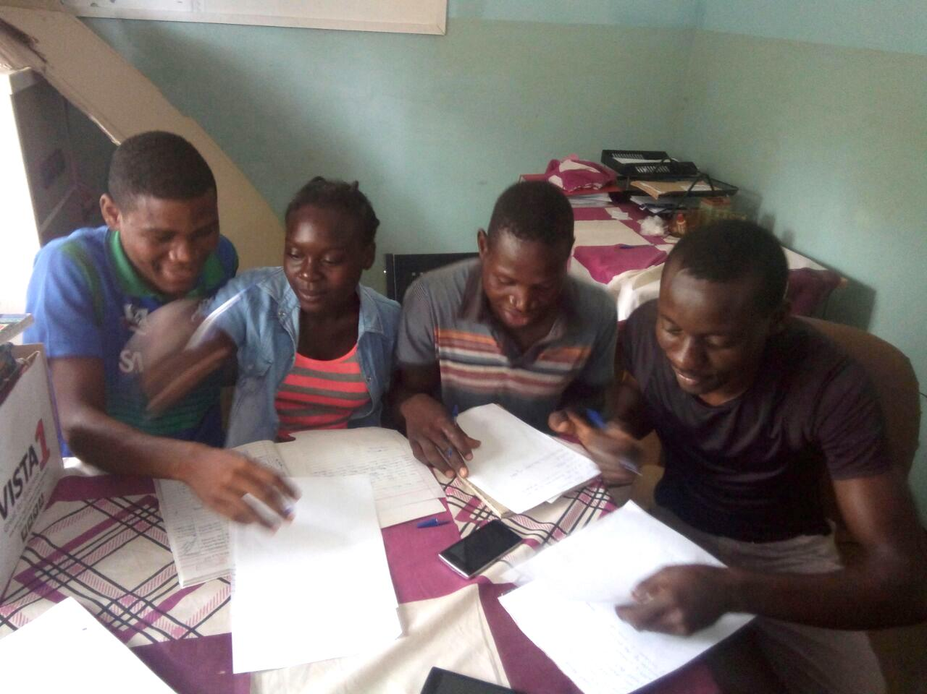
GROUP PHOTO OF THE FOUR CHILDREN

